**Project Overview:**

Niko Apparel Systems is a Hamilton-based company doing its fabrication business. Currently, they are handling their team’s orders by emailing back and forth. They are having trouble keeping track of the orders and tallying up the product sizes by putting everything in the excel sheet.

Now, Niko Apparel Systems order systems are handling the team’s order by emailing and transferring data to the Excel sheet which means more work for them. We are expecting to reduce this problem by bringing a web-based Team order system. It can get all the required information for the seller and the customers. Moreover, tallying up the sizes with the corresponding product categories is all done by humans. We all know that human error can happen every time and it’s a tedious job. By bringing this application can get rid of human errors. We make all these things work under one shed. However, we are pretty sure that we can bring more orders to our clients in a better and efficient way.

1. **Requirements**

**Functionality**

* There are two user roles for the order system: User and Admin
* Providing the customer details fields for the order through a web form
* Specifying the quantity, size, and colour of the products
* Submitting the order to the Niko Apparel through the support of the database.
* Reviewing the order by the customer
* Sending order confirmation to the customer and to the Administrator
* Tally up the product according to the size and product category and provide the number to the employer
* Adding and updating product details by the Admin
* Viewing and editing order by the customer

**Usability**

* The web application will run with the support of Browser
* The application can be viewed by the customer through a browser
* Will confirm all the uses by Testing

**Reliability**

* We will create automation testing scripts in Katalon studio for the website
* The script will sign in to the user or admin profile and will provide an order for a Team
* Testing with managing order with different users

**Performance**

* Expecting all responses within 5 seconds
* Making the code more reliable and adaptable to the environment.
* All features used in development will be updated as per the latest technology.

**Supportability**

* There will be IT contractors for giving support for web applications in case of any failures.
* The web-application will power-up from their current server
* The web-application will be documented properly so that it can be fixed quickly

1. **Use Case Diagram:**

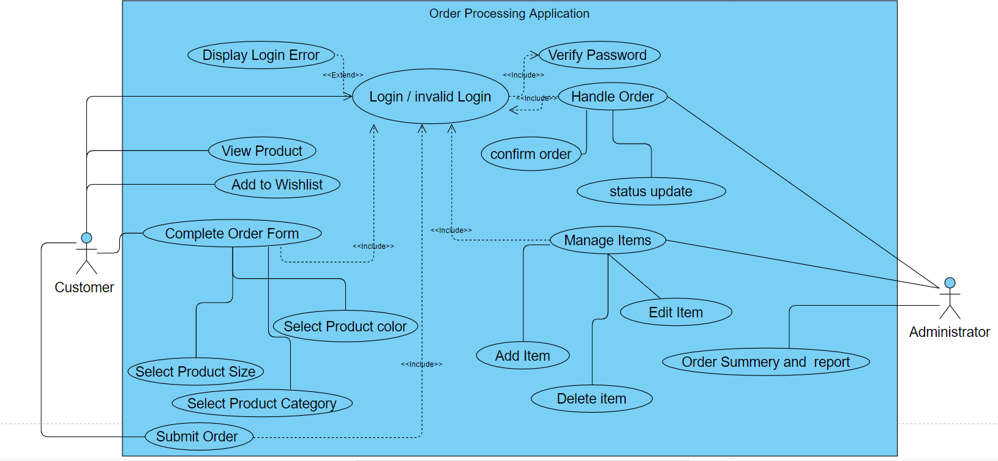

1. **System Architecture Diagram:**

The diagram shows the system architectural design where a connection is established with the web server through the internet. The internet browser is used to make a request to the web server and the web server transports the information between thePHP/JavaScript engine and the client. The middleware also interacts with the database to retrieve data from it or to store data into it from the application.

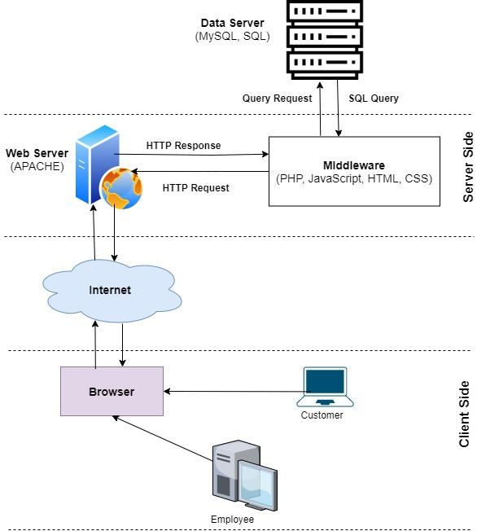

1. **Risk Analysis & Mitigation:**

The risk analysis table in the following contains possible risks for our project. We have used the following scales for the probability & impact metrics, and for measuring the risk level.

Probability scale:

|  |  |  |  |  |
| --- | --- | --- | --- | --- |
| Not likely - 0 | Less likely - 1 | Likely - 2 | More likely - 3 | Most likely - 4 |

Impact scale:

|  |  |  |  |  |
| --- | --- | --- | --- | --- |
| Minimal - 0 | Minor - 1 | Moderate - 2 | Significant - 3 | Severe - 4 |

Risk level scale:

|  |  |  |  |
| --- | --- | --- | --- |
| Very low: 0 - 1 | Low: 3 - 5 | Medium: 6 - 11 | High: 12 - 16 |

**Risk analysis table:**

|  |  |  |  |  |  |
| --- | --- | --- | --- | --- | --- |
| **Type of Risk** | **Risk ID** | **Description** | **Probability**  **( P )** | **Impact**  **( I )** | **Risk**  **Level**  **( P * I )** |
| Technical | Tec1 | The problem of deploying the application due to server unavailability. | Less Likely  1 | Severe  4 | Low  4 |
| Scope | Sco1 | A sudden requirement that was not realized before or the owner changes just before the deadline. | Likely  2 | Moderate  2 | Low  4 |
| Resource | Res1 | Failure to communicate with the client’s IT person. | Likely  2 | Significant  2 | Low  4 |
| Res2 | Group members not participating in the development or has a lack of skill in doing the project. | Not likely  0 | Moderate  2 | Very low  0 |
| Scheduling | Sch1 | Failure to identify a critical functionality may require extra time to complete that function. | Likely  2 | Moderate  2 | Low  4 |
| Competitive | Com1 | Similar high-quality software may exist from another source. | Not Likely  0 | Significant  3 | Very low  0 |

**Mitigation:**

|  |  |
| --- | --- |
| **Risk ID** | **Mitigation plan** |
| Tec1 | Communicate with the IT person and owner beforehand, rather than waiting for the last minute. |
| Sco1 | Set up a meeting with the client and contact the IT person to ensure the requirements of the application. |
| Res1 | If the IT person is not responding to email or picking up a phone call, we must contact the owner to make an alternative effort. Visit them in person if possible. |
| Sch1 | The project always needs to be tested properly. Automation testing may be useful for our project. |

**DESIGN DOCUMENT:**

**2.1 Home Page**

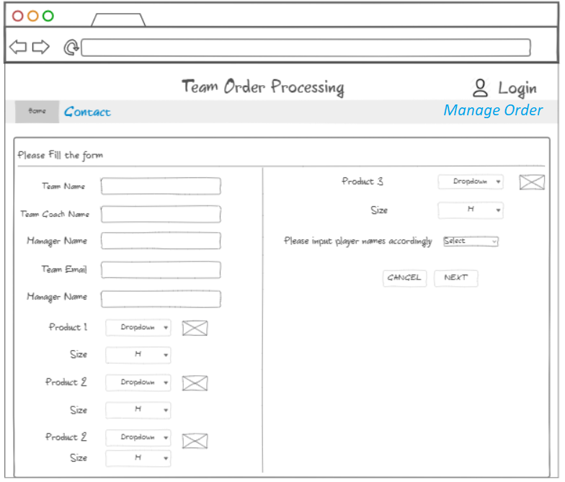

**2.2 Order Review Page**

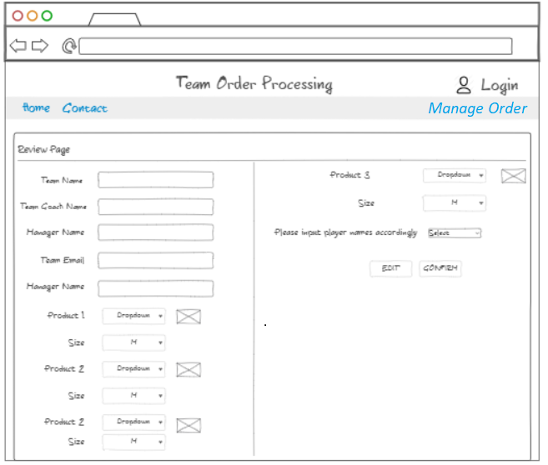

**2.4 Order Confirmation Page**

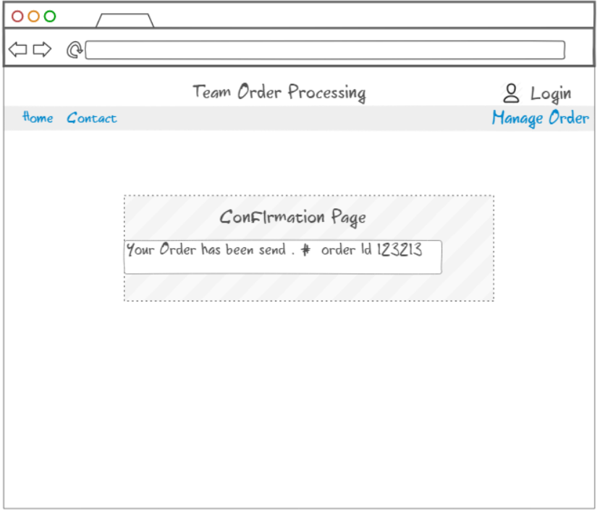

**2.3 Contact Page**

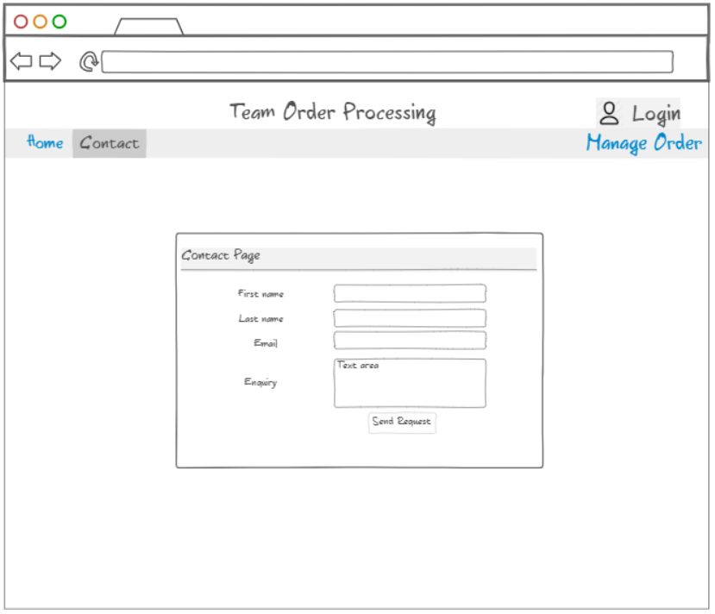

**2.5 Login Page**

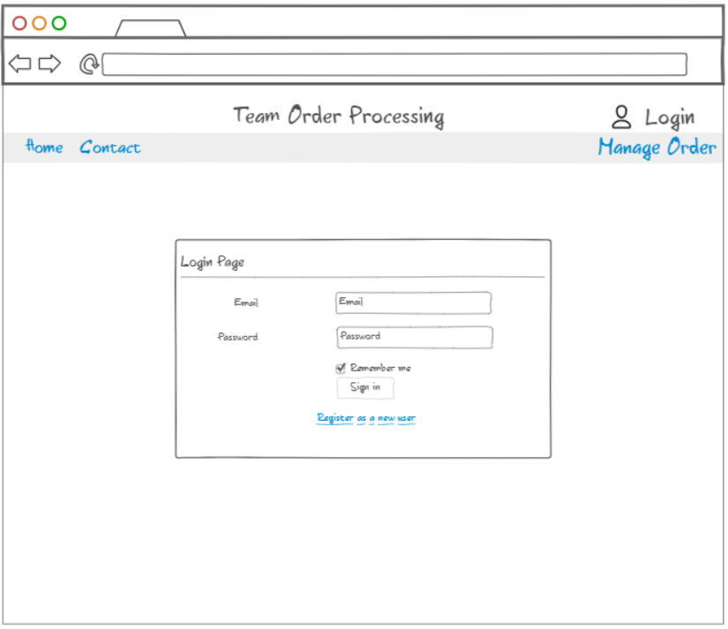

**2.6 Order Manage page**

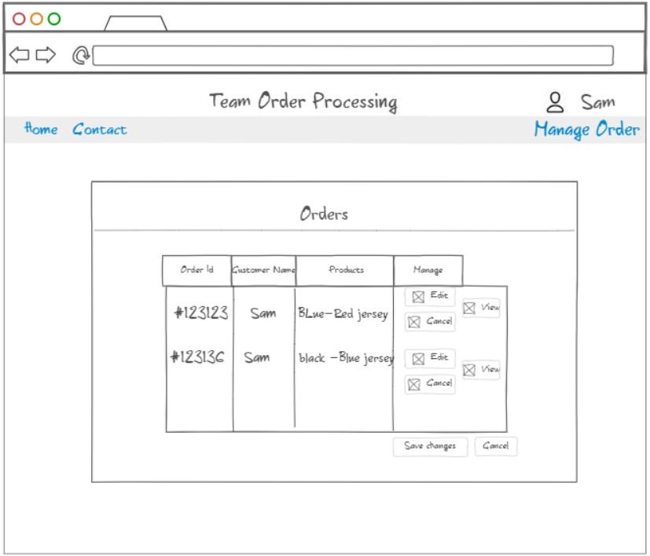

**2.7 Order Details Page**

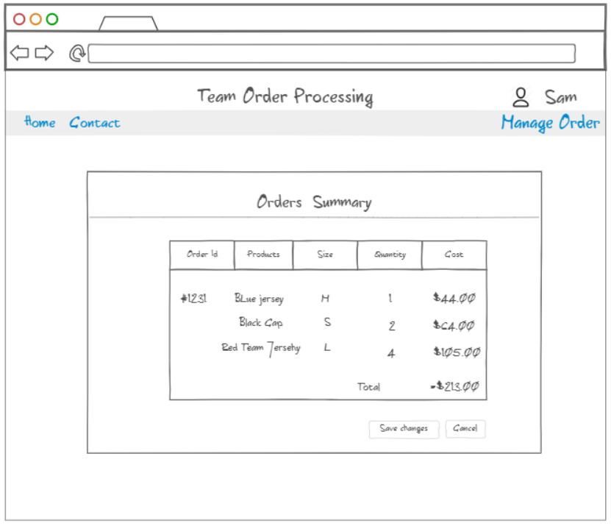

1. **Class Diagram**

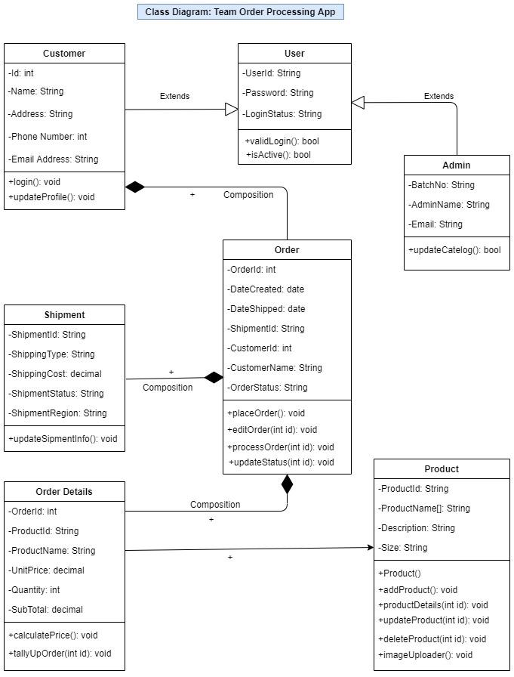

1. **Sequence Diagram**

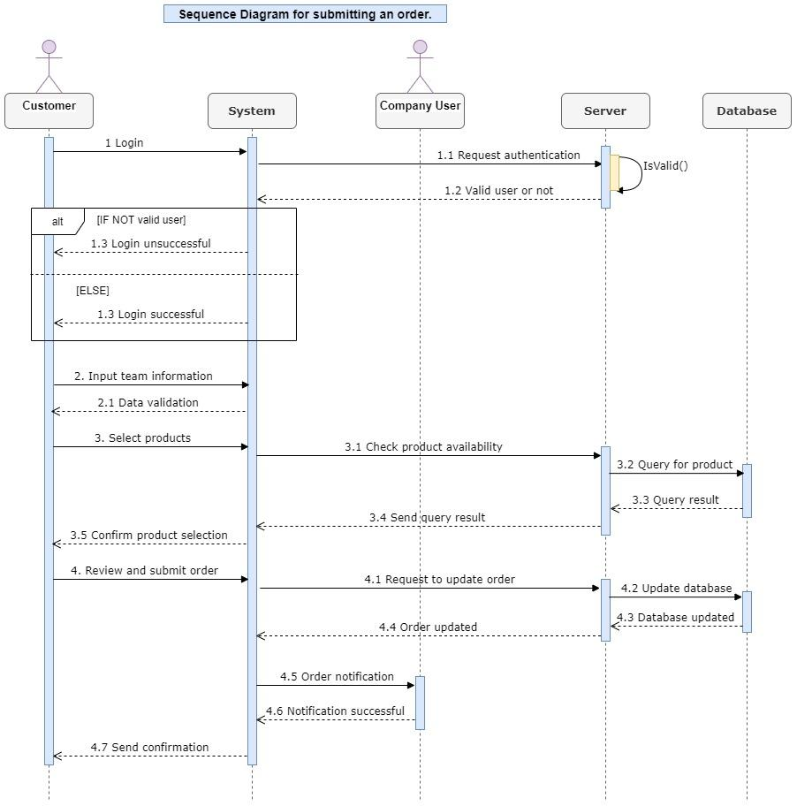

1. **Tools Table**

|  |  |
| --- | --- |
| **Development tools, Platforms, Components, Frameworks, Services & Design Patterns.** | **Description** |
| **HTML/CSS** | Cascading Style Sheet is used for styling appearances of content on a web page such as font size, color, etc. where HTML is used to create the actual contents for a web page. We will be using these two languages for our application. |
| **PHP and JavaScript** | PHP(Hypertext-Preprocessor) is a server scripting language that is used in web applications. JavaScript which is widely used in all websites as a client-side programming language and helps to make web page dynamic and interactive by implementing custom client-side scripts we will be using this PHP & JavaScript in our application |
| **Draw.io** | It's an online diagram drawing software for making flowcharts, UML diagrams, network diagrams, etc. This application helps to create our Class diagram and Sequence diagram. |
| **MySQL** | MySQL is an open-source relational database, used as a database management system. We will be using MySQL for creating the database, tables. |
| **Apache** | Internet information service is a web server that runs on the Windows system to serve the requested HTML page. It has its own process engine to handle requests. Requests are received from the local client’s computer and return appropriate responses back to clients. Apache is an HTTP server, which is an open-source platform. It allows a website to serve content on the web |
| **Visual Studio** | Visual Studio is an integrated development environment (IDE) used to develop programs for windows as well as a web application, it also helps in quick debugging, team collaboration and testing code. Most of the testing will be done in using this platform |
| **NinjaMock/Balsamiq Cloud** | This is an online platform for online wireframe and mock-up tool, this platform will be used to design applications and is the only platform which includes vector editor and we will be using this platform for our application |
| **GitHub/Git** | This is an open-source platform which controls system, manages and store projects online, mostly used for coding. It has a filling system for drafting documents changes to a project that can be made to the repository to your system first and then make changes to the central server. |
| **Bootstrap** | It's an open-source toolkit for developing HTML, CSS & JS. This framework helps you to design websites in an easier and faster way. It uses jQuery support in JavaScript plugins. We will be using this framework to develop our application. |

1. **Project Plan**

|  |  |  |  |  |
| --- | --- | --- | --- | --- |
| **Task** | **Task#** | **Start Date** | **Completion Date** | **Predecessor** |
| 1. **Gathering and installing necessary tools** | 1 | March 6 | March 7 |  |
| **2. Implement**  2.1 Initial project setup and home page  2.2 Login page  2.3 Creating database  2.4 Developing order submission form  2.5 Developing order confirmation page  2.6 Order management page  2.6.1 Order details page  2.7 Product management  (add, update, delete product, image,  price, etc.) | 2  3  4  5  6  7  8 | March 8  March 10  March 11  March 13  March 15  March 17  March 19 | March 9  March 10  March 12  March 14  March 16  March 18  March 20 | Task #1 |
| **3. Test**  3.1 Test home page, login page  3.2 Test order submission form,  confirmation page  3.3 Test Order management and  Order details page  3.4 Automated test (Katalon Studio) | 9  10  11  12 | March 21  March 22  March 23  March 24 | March 21  March 22  March 21  March 24 | Task #2 |
| **4.** **Fix bug** | 13 | March 24 | March 24 | Task #4 |
| **6.Test recently updated prototype** | 14 | March 25 | March 25 | Task #5 |